**Workout 2021-03-10, Template Pattern, CS 3667 Name: _Ian Apelgren________**

Instructions: You will work individually today. Answer question 1-3 in this document. Store the document in the root directory of the program you write for question 4. Zip up those files and turn in the zip file on ASULearn.

1. Write the Template Method Pattern Definition.

the steps of an algorithm and allows subclasses to provide the implementation for one or more steps.

1. Draw the generic Template Method UML using draw.io and copy an exported png image here.

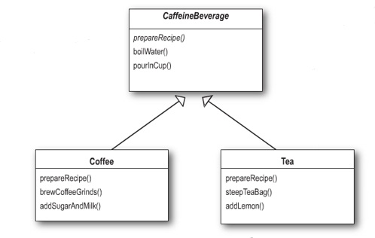

1. Hollywood Principle questions
2. State the Hollywood Principle.

you dont call us we call you

1. What is "dependency rot"?

its when you have high-level components depending on low-level components

1. What other patterns have used the Hollywood Principle? Explain.

factory method, observer, statagy

1. Consider the following Class Diagram: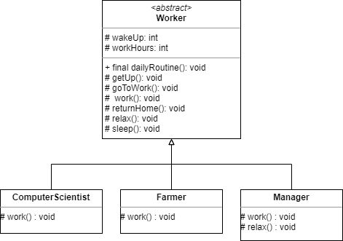

You are writing a program to process the daily routine for different types of workers. Write the Template pattern code for the problem shown below. Include a constructor in each class that initializes the getUp and work time. dailyRoutine is the template method; it simply calls each of the other methods in the order shown. Give default implementations for all methods except for work(). For all the implemented methods, simply print a line describing what is being done. In getUp() display the wake up time line of output. Make work() an abstract method.

In each of the subclasses, create an appropriate work method and override the default relax method in manager.

Finally, write a simple Client with main that instantiates each concrete workers and calls dailyRoutine on each.